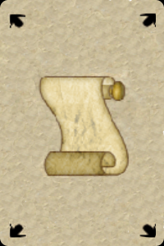  INITIATE | STUDENT | PRENTICE
JOURNEYMAN | SCRIBE | MASTER
  INITIATE | STUDENT | PRENTICE
JOURNEYMAN | SCRIBE | MASTER
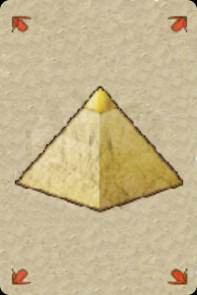  INITIATE | STUDENT | PRENTICE
JOURNEYMAN | SCRIBE | MASTER
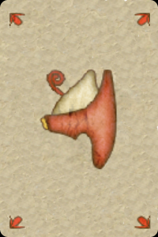  INITIATE | STUDENT | PRENTICE
JOURNEYMAN | SCRIBE | MASTER


